**ERP Software System's Shipping Management Solution**

**Meet shipping requirements on time, every time and at the most efficient cost**

Accurate shipping management is critical to an organization's cash flow, as shipments typically start the invoicing process. It is also an essential link in the customer's supply chain. Only EnterpriseIQ Manufacturing ERP Software System's Shipping Management Solution provides you a single solution to:

* Streamline the complete order shipping process for both domestic and international operations
* Meet shipping delivery dates 100% of the time
* Eliminate shipping errors
* Control shipping costs
* Respond instantly and accurately to customer delivery status requests
* Track and trace product shipments in real-time

Because of the breadth and cohesiveness that only EnterpriseIQ can provide, the Shipping Management process begins with the sales order through manufacturing, into the warehouse and beyond the shipping docks including:

* Automatic conversion of sales orders to pick tickets ensures accurate shipment information as well as inventory locations and quantities
* Bill of Lading may be printed for a single packing slip or a single BOL may be created for multiple packing slips
* Advance Shipping Notice (ASN) generation sends the customer prior notice of shipment details including packing slip information, shipment destination, terms of payment, carton/weight information and more
* Real-time communication between **UPS**® and**FedEx**® carriers
  + Determine the most efficient shipping method
  + Automatically generate the shipping documents and labels
  + Carrier tracking numbers are automatically populated in EnterpriseIQ
  + Provides complete shipment tracking and visibility
* Simplified logistics associated with International shipments with creation of commercial invoices, including multiple currencies, export declarations and NAFTA certificates of origin
* Container management monitors volume and weight of boxes and pallets that can fit into the container/trailer and automatically recalculates costs as items are added or removed to the pick ticket
* Certificates of Conformance can be generated automatically and will include the packing slip and BOM and transaction log details
* Integration with the [EnterpriseIQ Production Monitoring](http://www.iqms.com/manufacturing-software/production_monitoring.html) provides an up-to-the-minute view of production and inventory to ensure product availability matches delivery requirements
* Integration with [EnterpriseIQ Warehouse Management](http://www.iqms.com/products/erp/manufacturing/inventory/warehousemgmt.html) System (WMS) allows shipping lists to be created from anywhere in the warehouse through hand-held and PDA devices
* Through the [web portals](http://www.iqms.com/products/ebusiness_portals/customer_portal.html), customers can access real-time shipping details and status

#### Scope of Services

#### Freight Forwarding

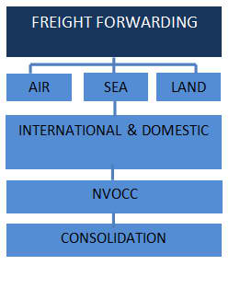

#### Customs Brokerage

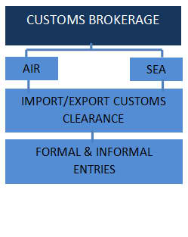

#### Logistics Services

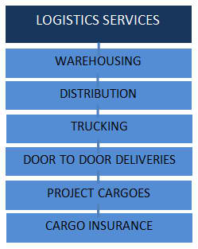

#### Courier Services

